|  |  |
| --- | --- |
| To: | Guido; C2T2 History File |
| From: | John Enrietto |
| Date: | 4/26/22 |
| Subject: | Lessons Learned |

Some issues from this lesson Include:

1. Converting from object type to Int type must include looking for NA *and* any non-integer data. Even a single cell in a variable/column/feature will not allow the column to be set as an int
2. 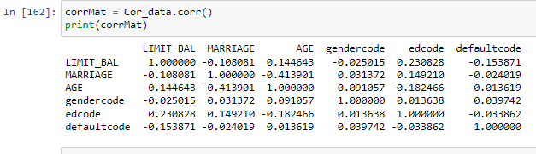None of the single feature to feature vectors showed any meaningful correlation. Neither the defaultcode column or the Limit Bal feature show a correlation to any of the (what I call input data): data the bank will have before any credit history.
3. Dummie did not seems to be much help to convert object data to int. It works but I don’t like to have to add four variables, and memorize syntax of a new technique. Instead I used for with imbedded if/elif and create a just 3 new variable. That seems more logical and easier to follow than does a shortcut I need to memorize.

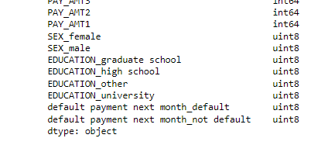

1. 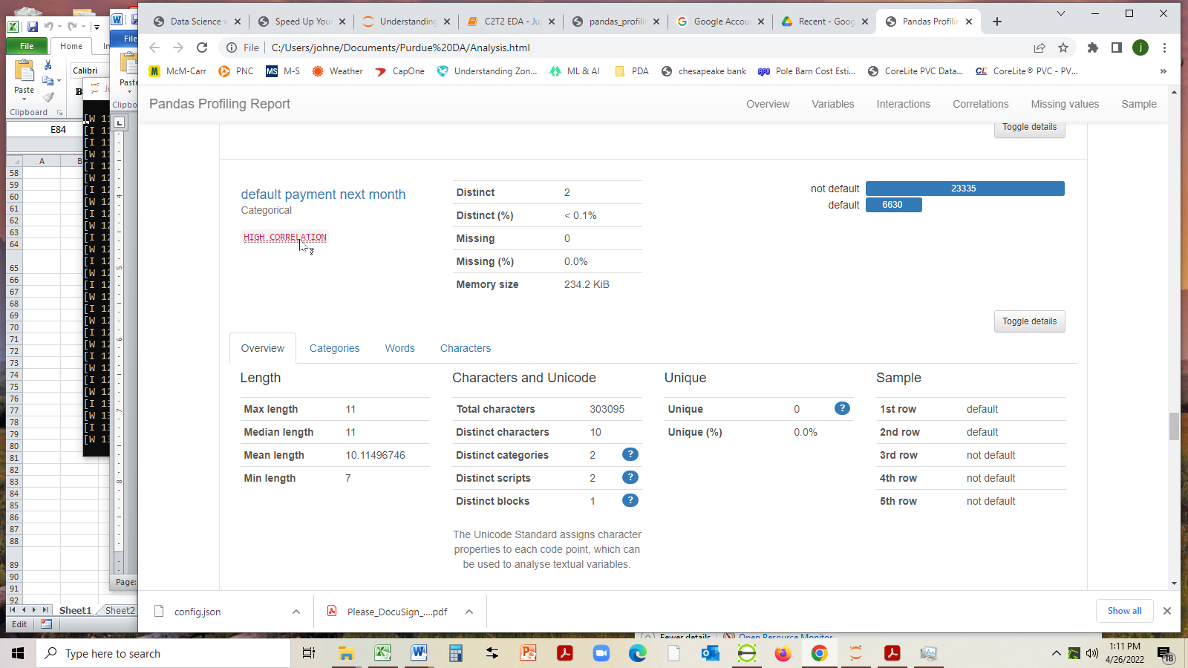Profiling did not appear to show much correlation, but one hint

Corr to Pay1

1. No Correlation , graphically

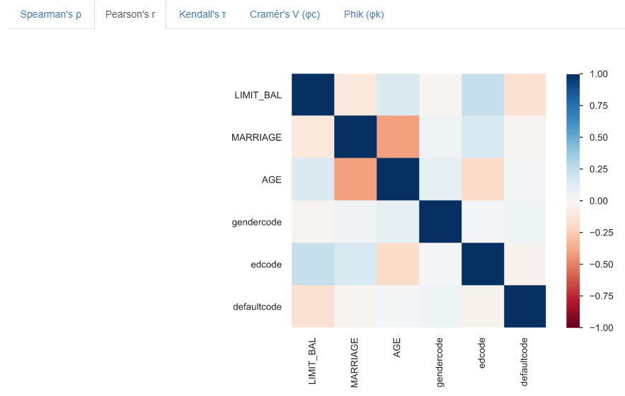

1. 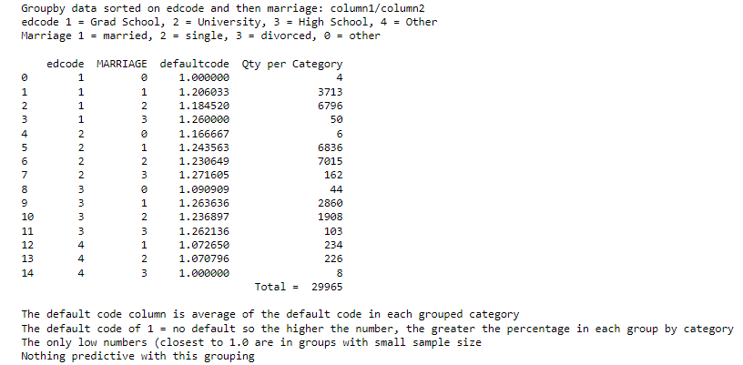Groupby did not find any correlation